Content: Surface area and volume

- ECR – A baseball has a diameter of 2.8 inches. Two dozen baseballs will be packaged in a non-overlapping cardboard box. There are four options for packaging.

Option 1 - 6 rows of baseballs, each row 4 balls long
Option 2 - 8 rows of baseballs, each row 3 balls long
Option 3 - Two layers of 6 rows of baseballs,
Each row 2 balls long
Option 4 - Two layers of 4 rows of baseballs,
Each row 3 balls long

Which of the above options require the least amount of cardboard? Use mathematics to explain how you determined your answer. Use words symbols or both in your explanation.

You are making a 2 layer round cake that has a diameter of 12 inches. Each layer is 3 inches tall. You will be using one layer of icing on the top of one cake. Then you will put the other cake on top of the iced cake. Finally you will ice the top and side of the assembled cake.

Part A.
If you need 1 cup of icing for every 5 square inches, how much icing (in cups) do you need to make in order to ice the entire cake? Use mathematics to explain your answer. Use words, symbols, or both in your explanation.

Part B.
When you cut the cake you will be cutting a smaller circle with radius 3 inches in the middle of the cake first. Then you will cut the smaller circle into 12 equal parts. The outer ring will be cut into 24 equal parts. What is the volume of one outer slice of cake? Use mathematics to justify your answer. Use words, symbols, or both.

ECR
Salt used for roads in icy weather is stored in cone-shaped sheds. The shed in Pocomoke has a diameter of 30 feet, and is 25 feet tall. At the beginning of winter, the shed is filled to capacity.

Figure is not drawn to scale
30 feet
25 feet

- Determine the volume of salt that is available at the beginning of winter. Use mathematics to explain how you determined your answer. Use words, symbols, or both in your explanation.
- In February, enough salt has been used so that the diameter of the pile of salt inside the cone is now 16 feet, and is now 12 feet tall. How much salt will the Pocomoke Highway Department have to order to refill the shed to capacity? Use mathematics to explain how you determined your answer. Use words, symbols, or both in your explanation.
- The shed in Ocean City is twice the diameter and height of the shed in Pocomoke. Worcester County is planning to paint the exterior of both sheds this spring. To order enough paint, the county needs to know the area of each shed that will be painted. Determine the area to be painted for each shed. Use mathematics to explain how you determined your answer. Use words, symbols, or both in your explanation.
Step 1)
We have spherical water tower with a radius of 100 feet. There is a machine that paints the water towers with a spray gun. If one gallon of paint covers 100 square feet, how many gallons of paint will be needed to paint the water tower?

Step 2)
The water tower in the next town has a radius twice the size. Justify why the machine will need more than double the amount of paint to cover the entire surface. Use words, number, and/or symbols to support your explanation.

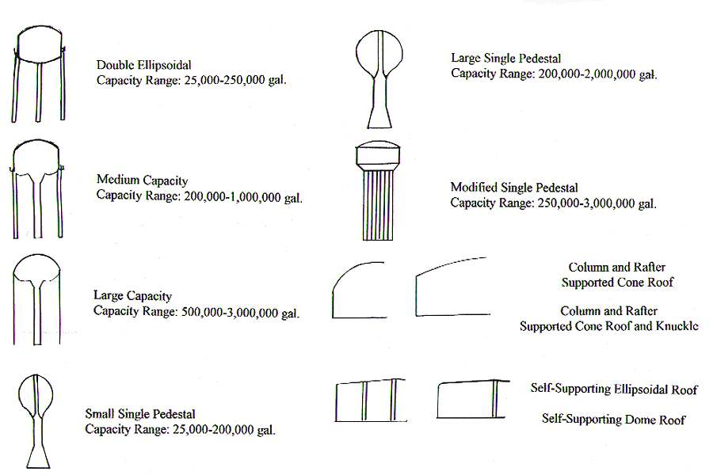

Given a cube with side length 3 cm, determine its volume and surface area.

Volume___________________ Surface Area__________________

If you triple the sides of the original cube, determine the volume and surface area of the new cube..

