COSC426 Software Engineering, (Team #5) Fall 2024
Week #:
Evaluator: McKirgan, Timmy

 | → | 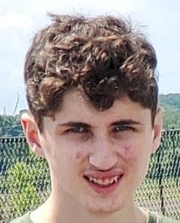 | 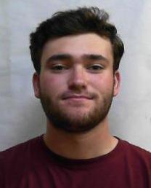
McKirgan, Timmy |  | Obrien, Dustin | Trafaglia, Kyle

Week #1 accomplishment by member
Member | List of tasks from the previous Wednesday | Completion Rate %
Obrien, Dustin
Trafaglia, Kyle

Member | Weekly Team Contribution Rate by Member %
McKirgan, Timmy (self)
Obrien, Dustin
Trafaglia, Kyle

Comments:

