COSC426 Software Engineering, (Team #2) Fall 2024
Week #:
Evaluator: Pham, Vincent

 | → |  | 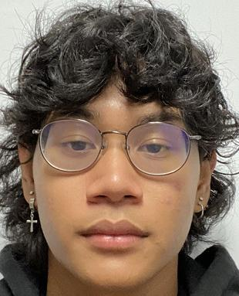
Pham, Vincent |  | Gammel, Nicholas | Lamuth, William

Member | List of tasks from the previous Wednesday | Completion Rate %
Gammel, Nicholas
Lamuth, William

Member | Weekly Team Contribution Rate by Member %
Pham, Vincent (self)
Gammel, Nicholas
Lamuth, William

Comments:

