COSC426 Software Engineering, (Team #3) Fall 2024
Week #:
Project Title:
Client:
Team Leader:
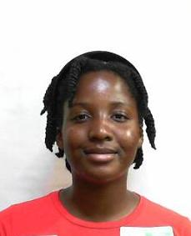 |  | 
Cesar Alberi, Stephora | Verduzco Zvala, Jorge, Amando | Pinckneyh, Jordan

Next Week Tasks for each member
Member | List of Tasks for Next Week
Cesar Alberi, Stephora
Verduzco Zvala, Jorge, Amando
Pinckneyh, Jordan

Client Meeting Summary:

