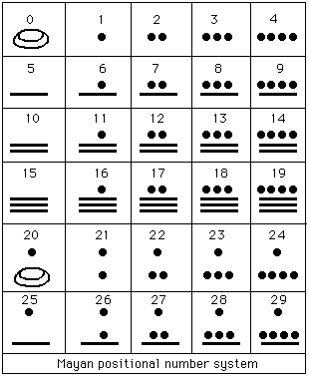
chinese rod numeral system- used on a counting board (prior to abacus)
“Base 10” with columns. The number in the tens column is turned 90 degrees.

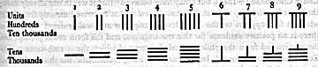

An abacus. Used in China about fourteenth century AD.

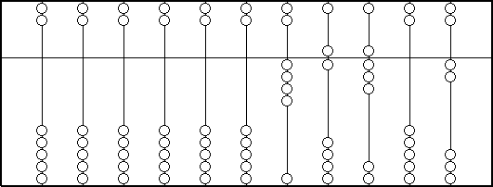
The quantity
46802 on an abacus, what would
607, 334, 304589 look like?

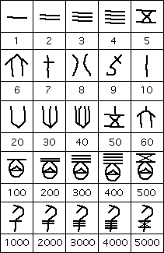
A selection of traditional Chinese numerals- note how the larger numerals are built multiplicatively from the smaller values
This system is also “additive” (up to a certain point) in that one placed the numerals next to one another and added up the values to get the value of the entire expression.

Babylonian numerals (inherited from Sumerian and also Akkadian civilizations)- possibly used in a mixed radix system of bases 6,10 (1900 BC to 1800 BC?). Built from 2 symbols.
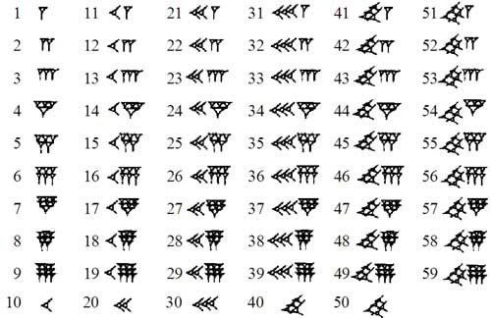
extra on mixed-radix system
32 weeks, 5 days, 7 hours, 45 minutes, 15 seconds, and 500 milliseconds might be rendered relative to minutes in mixed-radix notation as:
... 3, 2, 5, 7, 45; 15, 500 , or as
... 10, 10, 7, 24, 60; 60, 1000

3₁₀2₁₀5₇7₂₄45₆₀.15₆₀500₁₀₀₀

Egyptian hieroglyphs
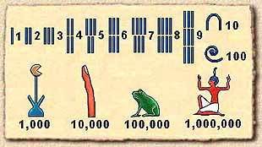Seven different symbols.
1 is shown by a single stroke.
10 is shown by a drawing of a hobble for cattle.
100 is represented by a coil of rope.
1,000 is a drawing of a lotus plant.
10,000 is represented by a finger.
100,000 by a tadpole or frog
1,000,000 is the figure of a god with arms raised above his head.
Excerpted from: http://www.saxakali.com/COLOR_ASP/historymaf5.htm

Roman numerals – cute converter at http://www.novaroma.org/via_romana/numbers.html
I one
V five
Placing a bar over the top of any of these, translates to “multiply by 1000”. So,
$\bar{C}$ has value 100,000

X ten
L fifty
C one hundred

D five hundred
M one thousand

Conventions for representing other numbers not listed above:
Place a smaller number in front of a larger one means “subtract” to get the value. A smaller after a larger means “add” to get the value. So…
VI is of value 5+1=6, but IV is of value 5-1=4; CX is of value 110 but XC is 90.

Ionic numeral system (additive system)

Letter | Value | Letter | Value | Letter | Value  β´ λ´ has value 32.  , λ´ β´ has value 30,040
α´ | 1 | ι´ | 10 | ρ´ | 100
β´ | 2 | κ´ | 20 | σ´ | 200
γ´ | 3 | λ´ | 30 | τ´ | 300
δ´ | 4 | β´ | 40 | υ´ | 400
ε´ | 5 | ν´ | 50 | φ´ | 500
ϝ´ or ς´ or στ´ | 6 | ξ´ | 60 | χ´ | 600
ζ´ | 7 | ο´ | 70 | ψ´ | 700
η´ | 8 | π´ | 80 | ω´ | 800
θ´ | 9 | ϟ´ | 90 | ϡ´ | 900

To represent numbers from 1,000 to 999,999 the same letters are reused to serve as thousands, tens of thousands, and hundreds of thousands. A comma or inverted acute is put in front of thousands to distinguish them from the standard use.

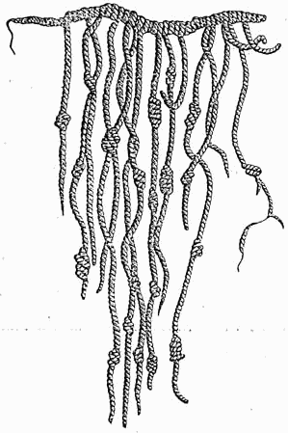
A quipa- a recording device used in the Inca Empire.
Consists of colored cotton cords with numeric and other values encoded by knots in a base 10 positional system.

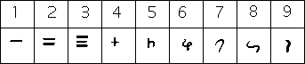

Hindu numerals- bottom row is earliest known form

