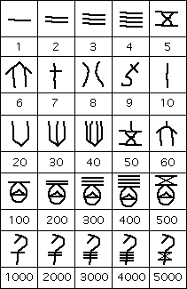
There was also a symbol for 10000 which we have not included in the illustration above but it took the form of a scorpion. However larger numbers have not been found, the largest number discovered on the Shang bones and tortoise shells being 30,000.
Add up the symbols: 4359 would appear: 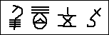
Now this system is not a positional system so it had no need for a zero. For example the number 5080 is represented by: 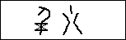
Here is 8873: 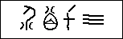 the 70 has the “ten” mark tilted over the 7

