Trees 101: Changing Forest Ecosystems
Megan Green

Yesterdays Land: A Dream Walk

Today, the most common tree found in Wicomico County is the Loblolly pine. The majority of these trees are found growing in even aged plantations for commercial purposes but they are also found growing in the more natural forests of the area. Over time we have changed the forest composition in Wicomico County from its natural diverse state to being dominated by these even-aged loblolly pine monocultures. This loss of biodiversity negatively impacts the animals that live in the forest as well as the quality of the water, air, and even the soil. Because of these negative impacts we should strive to restore biodiversity to our forests; however we need to find a balance between restoring biodiversity and using the forests for products. Let’s go back in time and see what the forest landscape may have looked like in the past compared to the forests of today. Then we can look at the role these different forests play in the factors I mentioned above.
Imagine that you have just ventured out for a walk into a Wicomico County segment of the newly state acquired Chesapeake Forest Land. The Chesapeake Forest consists of 58,000 acres of segmented forest land. It was recently purchased by the Conservation Fund from Chesapeake Forest Products Corporation, and then given to the state of Maryland. The Chesapeake Forest Lands are not the only forests in Wicomico County, and they have recently become productive forests, as they were previously owned by a logging company. I will use the Chesapeake Forest Lands in this paper as an example of a typical forest in Wicomico County because intense surveying has been done by the State of Maryland on the composition of these forested lands. You have wandered around for some time when you decide to sit down under a peaceful Loblolly pine to take a nap. When you wake up you find yourself in a dream world; this dream world is a forest of the past. There is a “great variety of woods, not choked up with under shrubs, but commonly so far distant from each other as a coach of four horses may travel without molestation.” This description of historic forests of Maryland was actually written by Father Andrew White, who explored the Western Shore of Maryland. We may infer from writings of the crew of John Smith that the Eastern Shore was just as bountiful. One passage describes the “Wighcocomoco” as being bountiful with fish and fowl, and describes that beyond the shore the land is covered with wood like the rest of the country. It is again later stated how overgrown with wood the Eastern Shore was, that as far as they could see there was no end to it. It is likely that you would find yourself overwhelmed with the variety of sites in front of you, never before have you seen so many visual treats.
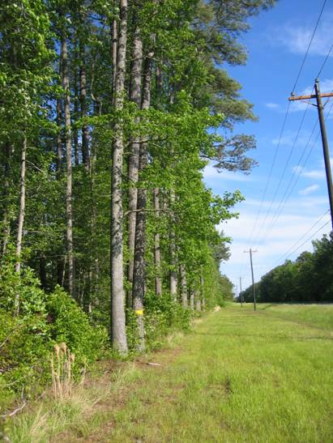
The yellow mark on the tree indicates that this is a part of the Chesapeake Forestland.
Source: Megan Green
As you walk on you begin to notice many trees that you have rarely ever seen before in combination with those that you are familiar with. You stop at the base of one and look up at its grandeur; it is a sweet gum tree which is still common here today as they do well in the wet soils of Wicomico County. A variety of animals use the sweet gum tree for both food and for shelter. The seeds of this tree are eaten by squirrels, chipmunks and even many kinds of birds. However if they are not able to mature into adults of at least 20 years they will not produce any seeds. Sweet gum seedlings can serve as a food source to mice, deer and other grazers. Sweet gum trees often act as pioneer plants, or plants that sprout first in an open field. These trees are often found growing very successfully along stream banks which makes them very important in preventing erosion of streambeds and preventing excess nutrients from running into the water.

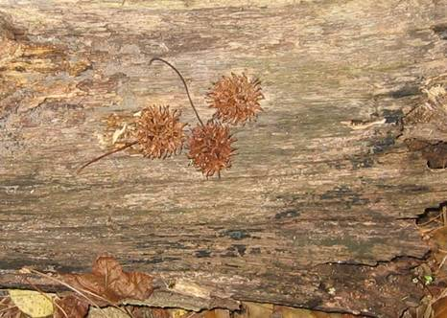
Sweet Gum seed pod.
Source: Megan Green

As you move on you take note that you still have not passed a single access road, a man made ditch, or a single monotonous patch of growth. The only clearing that you may encounter is an area that has been cleared by an Indian burn. You come upon a mighty willow oak that towers above you, the girth so large that it would have taken three people to wrap their arms around it. Oak trees are of great importance to many of the animals that call the forest home. The fruit of oak trees are acorns. Acorns and other hard mast fruits are important for wildlife because they provide a food source that can be stored and last into the less productive months of the winter when food is often scarce. Other oak species that could have been encountered in this forest include white oak, pin oak, and cherry bark oak.

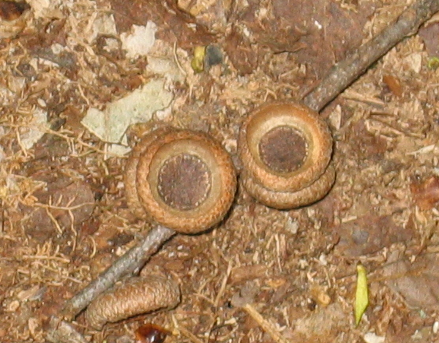
These white oak acorns are eaten by many animals.
Source: Megan Green

Well, that’s History

While some of the information that we have on what forests of the past may have looked like is partially assumption there is some harder evidence that can help to back it up. Charcoal samples recovered from a well in Webb’s Landing on the Murderkill River that are dated to 1690-1720 have left behind some evidence of what Eastern Shore forests may have appeared like so many years ago. Evidence from this well indicates that at one time oaks, pines, chestnuts, hickory, ash, poplar, cottonwood, butternut ash, sweet gum and willow trees all grew together in this geographical region. This well is in Kent County of Delaware, near Wicomico County. Since the well is located in the same region as Wicomico County it can be extrapolated that the same type of soil and growing conditions would be found at the two locations. A situation in which all of these trees would be found together would most likely be a “drier, interior, upland setting.” Forest types in aboriginal times were most likely oak-hickory, oak-gum, or oak-pine. These forest types do not mean that the trees listed are the only trees that will grow there but rather those trees growing together are indicative of the other trees that may be found in that forest. The trees listed are the dominant trees in that type of forest, and the combinations listed are the identifying species for that particular type of forest.
Other evidence for what historic forests of the Lower Eastern Shore may have looked like comes from a witness tree survey conducted by Dr. Christopher Briand and Dr. Michael Folkoff of Salisbury University. After doing a survey of 103 Eastern Shore witness trees they calculated the percentage of hardwood and softwood trees that may have been present in the 17th century. Witness trees were commonly used to mark property boundaries during the 17th century; they were usually larger trees that were found near the corner of people’s property. It was found that in Wicomico County the composition was probably 81% hardwood and 19% softwood. Tree species that they found documented as witness trees included white oak, red oak, hickory, poplar, gum, cypress, and pine.
There is some controversy over when the real human impact on forests in this region began. Some sources indicate that the forests of Maryland were essentially untouched before the first settlers arrived. In this case Native Americans are thought to have had minimal impact on land, clearing only small patches for hunting, agriculture, and protection reasons. Other sources indicate that a more drastic impact was made by the Native Americans burning techniques describing that they cleared plots on the floodplain through “slash and burn” and when one plot was depleted they would move onto the next. An article written by J.L Kirwin and H.H Shugart discusses the effects of fire on forest composition. Their study indicates that fire did play an integral role in shaping forest composition of today. However I am not sure that this means that the burning was done intensely by Native Americans. Evidence seems to point in the direction that although Native Americans did exploit the land to some degree based upon descriptions of the land by early settlers they had a small impact in comparison to the European settlers. This can at least be partially attributed to their smaller numbers. Either way, the widespread clearing of Maryland’s forests, due to agriculture and then industrialization, began in the 18th century.

New Beginnings

In the distance you spot a ray of light shining in, onto the forest floor dancing on the leaves. An old pine tree has lived the full course of its life and has fallen onto the forest floor to be returned into the nutrient cycle from which it came. You may not realize it but this dead tree is now home to a more diverse community of life than when it was a living part of the ecosystem. While the dead tree still stands it serves as an important habitat for a whole range of species from microorganisms to birds and bats. Susan Loeb, a biologist, did a study to compare a pine forest with a lot of woody debris to one that had all of the debris salvaged to see if either situation served as better habitat for forest mammals. She found that the density of small forest mammals was greater in the forest where the deadwood and fallen tree had not been salvaged. Some mammals that were collected from the site with deadwood present were not collected at all from sites where the deadwood had been cleared. These findings stress the importance of deadwood to forest creatures. They show that with the absence of woody debris comes the absence of forest animals that use the debris as habitat.
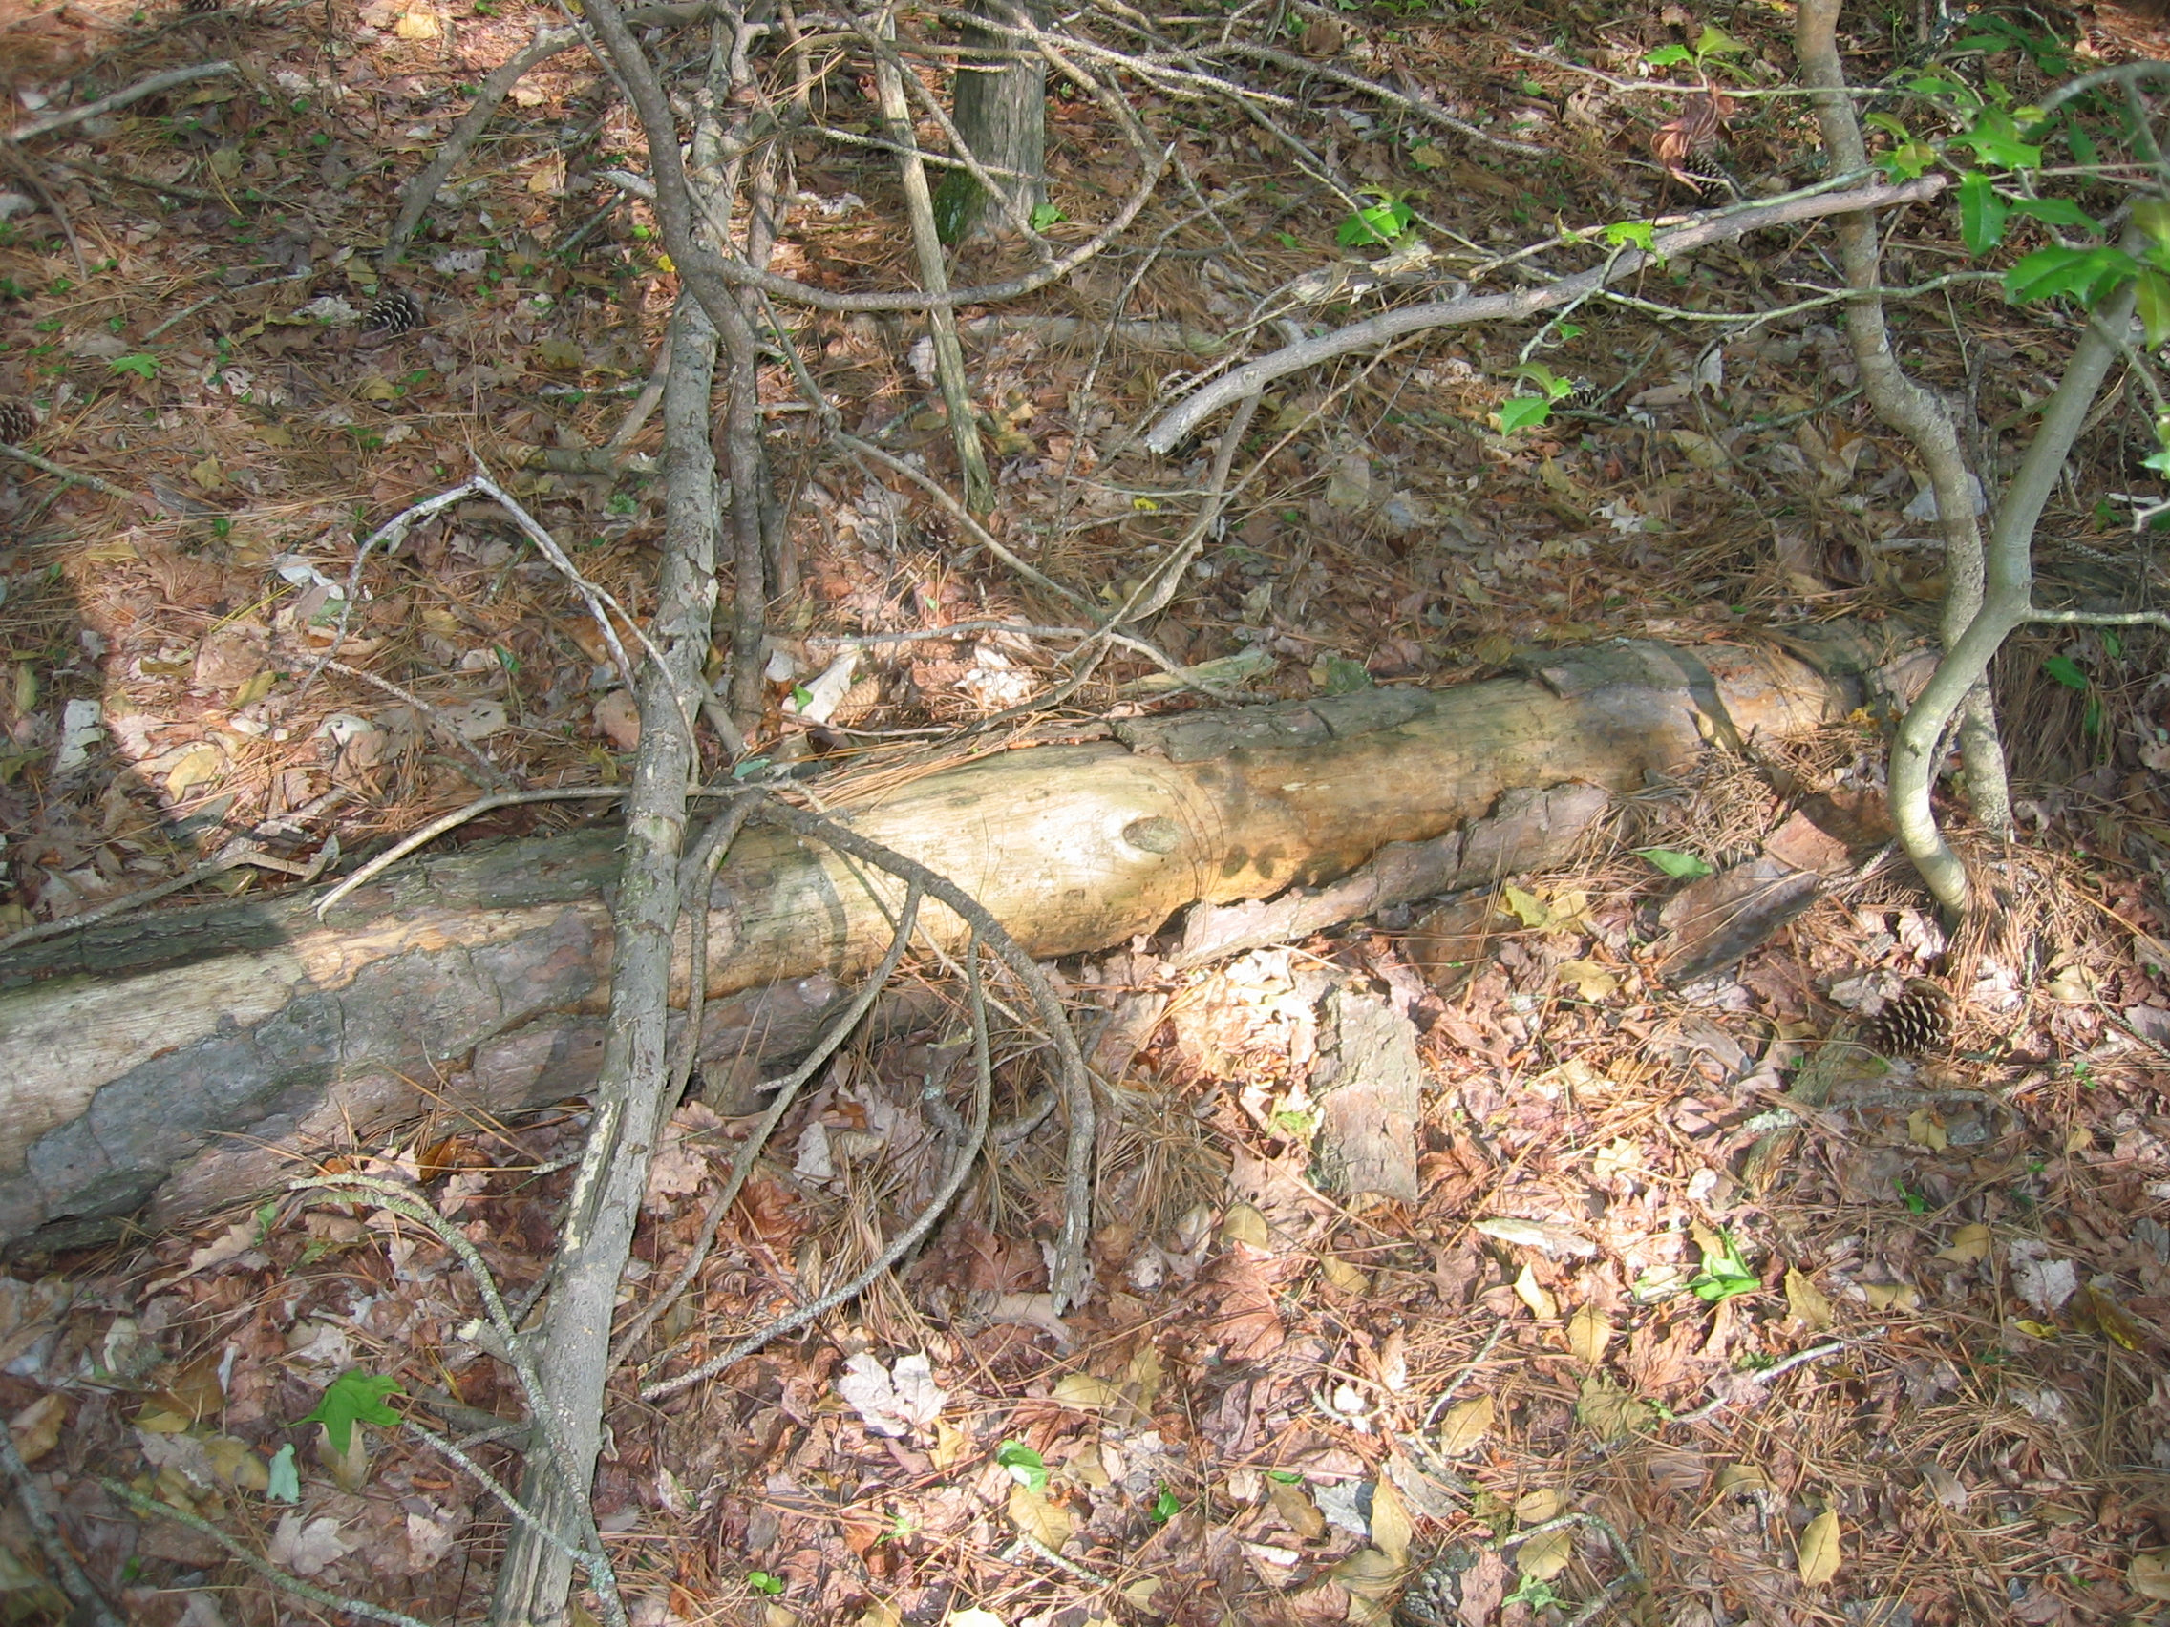
A fallen tree in Chesapeake Forest Lands.
Source: MeganGreen
When the tree falls it acts to support new life and plays a vital role in the forest and in aquatic habitats. If the debris falls into a waterway it can become home to aquatic organisms such as fish, crabs, and detritivores. Hollowed out trees can serve as an important habitat for nesting mammals such as the Delmarva Fox Squirrel. The range of organisms involved in the actual breakdown of the dead material are numerous, and currently the function of each organism involved is still a mystery. Researchers in the United States have shown that in true old growth forests there may be as many as 100 snags, or dead trees, per hectare. From the time they die to the time they fall and decompose back into the ground that sprouted them, these trees can spend up to 340 years providing habitat and nutrients to other species which may depend on it.
Fallen trees also create a break in the canopy. The new light shining in allows for new plants to thrive on the forest floor that would not normally be found under the dense shade of this forest. Allowing for these species to grow in the forest is another very important part of the forest ecosystem. The plants on the ground provide a different source of food and habitat for forest animals than do the tall trees. Also, keeping many layers of active growth in the forest, aids in the retention of soil nutrients, and prevents them from running off into nearby streams.

This Story Has No Climax: Natural Succession
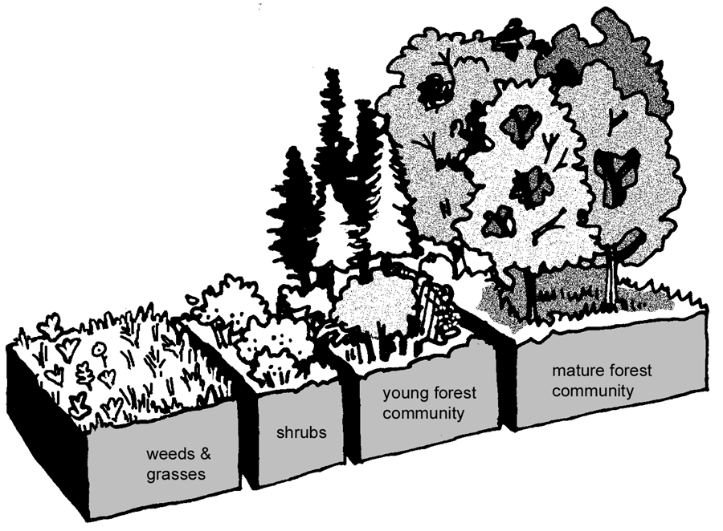
This sketch shows how an open field will progress into a mature forest showing the stages of succession.
Source: The Maine Tree Foundation

The forest situation that I have just described is how the natural succession of a forest begins. To think that without human interaction forests would remain a static ecosystem is far from the truth. In a forest that was left to run its natural course a series of changes would occur within the forest, even without the interference of man. We can start by describing an Eastern Shore forest after a natural disturbance. In the first stage after a disturbance the forest would not be a forest but a field with many small plants such as horseweed and aster. After the first year the horseweed will disappear and will be replaced by other small weed plants (this step is often unpredictable). Between three and five years after the disturbance broomsedge will dominate the field for a few years. The first trees to re-inhabit the forest are usually pine such as loblolly and yellow pine as well as some mixed hardwoods including sweet gum and red cedar. The pines dominate because they are fast growing. They will begin to produce a dense canopy. In this shade, sun loving young pines will not grow well, but some maples will begin to sprout up. The pines will still dominate the landscape until about 50 to 100 years after the disturbance. At this time oak trees will begin to dominate, accompanied by maples, hickory, holly, and if the conditions are dry enough, cherry. There is some evidence that baby oak trees actually do not germinate well in the lower light conditions produced by the other larger oaks. This indicates that if we had any true old-growth forests in this area they would most likely be dominated by maples and cherry trees. These trees grow up to produce the understory of the forest. This change over time is called forest succession.
This description of forest succession is true of the many upland forests that we have here in Wicomico County. The types of trees that I have mentioned in this succession are similar to those found in the charcoal samples of the well in Kent County that I mentioned earlier. However, there are also many wetland forest areas in this area. In a wetland forest the species composition would be much different. These forest would include bald cypress, swamp red maple, green ash, black gum, sweet gum and in a few spots Atlantic white cedar trees. Some oaks could be found here such as the swamp chestnut oak which can tolerate the flooding better than other species of oak. Holly would also be present in these forests because it can grow both in the drier upland soils as well as in the wetland forests. Wetland forests go through typical succession stages like their drier neighbors, however the species involved differ correspondingly.
So even in the absence of humans forest composition would be changing. However these natural changes would have been different from the changes we impose. After each natural disaster the succession would start again. Pine dominated forests would live long enough to make the change over to hardwood forests. In the past, after the change from pine to hardwoods has occurred the forests were considered climax forests. A climax community is one that has reached a stable stage. This means that the forest would be static, that there would be no more change in forest composition. The simple, less diverse communities that first inhabited the open field have been replaced by the more complex communities composed of larger trees. However this idea of a stable climax forest has now been rejected by the scientific community because in reality, this forest is not stable. One tree may fall down, knocking over another, creating a bright open space in which a new pine may begin to grow. Lightning may strike clearing a patch within the forest which will again let it light and allow the sun loving plants to take over that patch. Even climate may change over time, changing the composition of the forest since different plants are able to grow in different climates. Obviously the plants that we see here are the not the same plants that would be found in Alaska or the Caribbean because the plants that grow there are adapted to the specific zone in which they live.
Forest ecosystems can never reach a stable state, at least not naturally. Today, it is almost like we are the ones creating the climax forest, as we select for the trees and plants that we want to grow in the ecosystem. We stop this natural change, the succession of the forests, and we create the climax situation, which in many forests on the Eastern Shore of Maryland is the Loblolly pine monoculture. Every time the trees are harvested, other plants may try to grow up in the open field, however herbicides and thinning prevent them from doing so. The Loblolly pines never reach an age where they are old enough to fall over and create a clearing, and if they are struck by lightning it is my guess that the patch that is cleared will be managed in the same manner allowing only another loblolly to grow there. We therefore are creating a stable situation in the forest. Now let us take a look at the forests of today, and see how they have changed into this stable monoculture.

Forests of the Present: Wake up Call
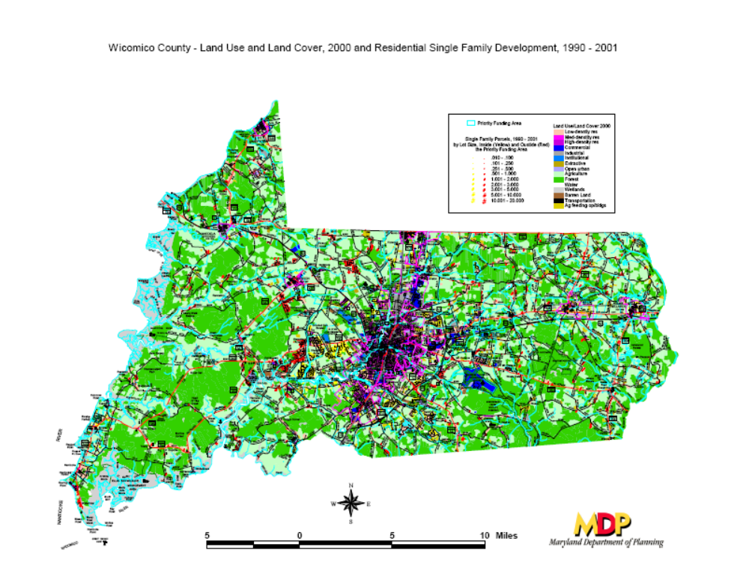
A map of Wicomico County Land-Use.
Source: Maryland Department of Planning

Wicomico County is located on the Lower Eastern Shore of Maryland bordered on the east by the Nanticoke River and bisected by the Wicomico River. The county is made up of 1,032 square kilometers. Of those approximately 42% are forested (a decrease of 4% since 1916), about 38% are in agriculture, and the rest of the land is developed or commercial. It lies within the south-eastern portion of the Coastal Plain Provence of Maryland. Soils of this region are generally poorly drained in comparison to the rest of Maryland due to its lower elevation. In Wicomico County specifically, most soils are poorly drained, however there is small portion of well drained soils, a small section of tidal marsh soils and some sand and silt association portions. The types of soils present in an area are both a product of and responsible for the types of trees that grow there. Certain trees, such as white oaks, can not grow in poorly drained soils and prefer drier conditions. Others, such as the Bald Cypress, prefer very wet swamp like conditions. If the soil in an area is not suitable for a specific type of tree, that tree simple will not be found growing there. The trees contribute to the composition of the soil because when they lose their leaves they are broken down and become part of the soil.
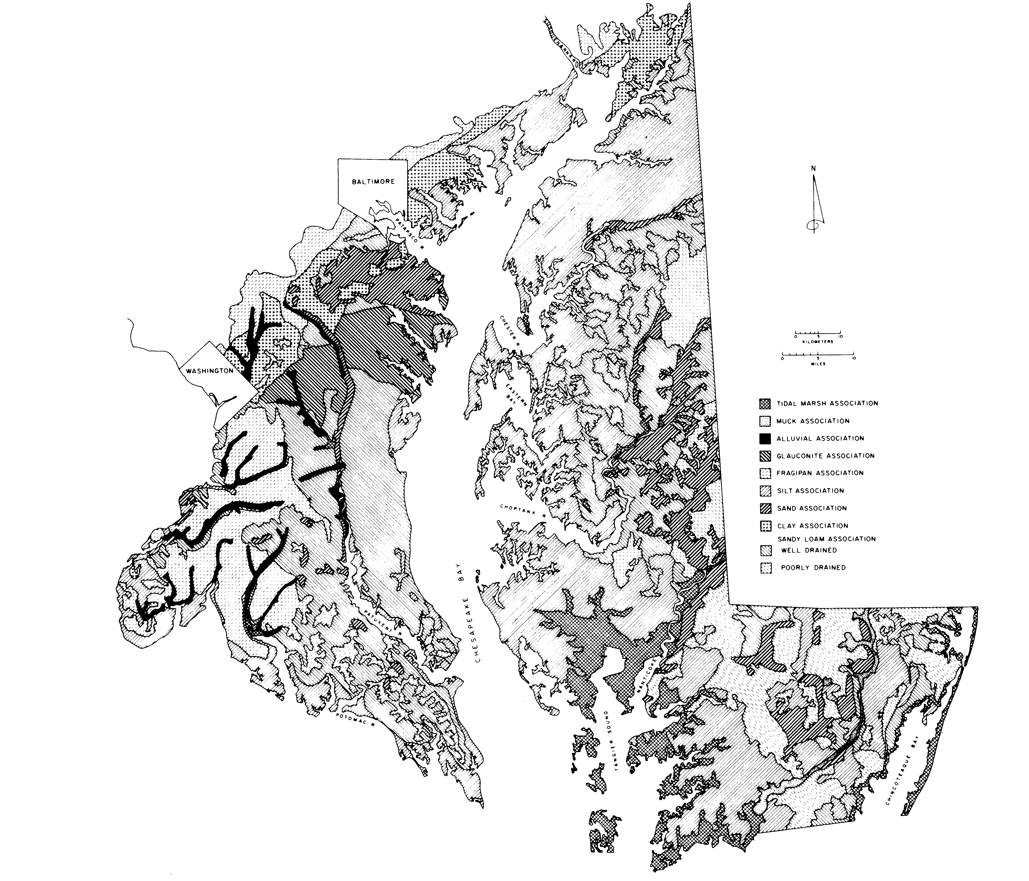
Soil Map of the Coastal Plain Provence
Source: Grace C. Brush
Currently the types of forests that can be found in Wicomico County are pure pine forests, a small amount of mixed hardwood forests, mixed hardwood-pine and pine-hardwood forests as well as cypress and other swamp tree forests. Loblolly pine is currently the most abundant tree species found. This can be attributed to the monetary incentives associated with growing loblolly pines since they are the most lucrative tree here on the Eastern Shore.
Incidences of red maple have also increased over time; reasons for this increase are not known however there are some hypotheses. One likely explanation is that the heavy burning done by Native Americans decreased the incidence of the maples because they are fire sensitive, and with a decrease in the burning the trees have been more successful. Other tree species that can currently be found in the area include oaks, sweet gum, beech, dogwood, holly, cypress and others. I was unable to locate a complete list of the trees that can be found currently in Wicomico County.
The State Department of Forestry has estimated that Maryland was about 90% forested before human contact. Today less than half of that is still forested land in Wicomico County. Much of this forested land has now been converted from the once fruitful and diverse natural mix of pine and hardwoods to a complete monoculture of Loblolly pine. While Loblolly pines were certainly a part of the historic forests of Wicomico County they were not found in pure stands until after the hardwoods had been cleared by the settlers or the Native Americans. Every patch of woods on the Delmarva Peninsula has been cleared and logged repeatedly.
So let’s say that you wake up from your dream now and really went for a walk in the forest where you were sleeping. Would the sites that you would encounter be similar to those from your dream? Different? More exciting? Disappointing? If you were to wake up in a Wicomico County plot of the Chesapeake Forest the first thing that you would probably notice is that the only litter on the ground is pine needles. Acidic pine needles. In a survey completed in 2005 on the forest composition of the Chesapeake Forests it was noted that 81% of the land was pine forests which are defined as forests that are composed of at least 90% pine. Mixed hardwood forests, which are defined as those that are dominated (no percentage is given) by hardwoods, make up only 12%. This landscape is obviously much different than the historic forest landscape which was dominated by mixed hardwood forests. While many of the trees found here have remained the same, the compositions of the forests have changed.
As you look around everything looks much more familiar to you now, you can identify without question every tree in front of you. They are, for the most part, all small enough for you alone to reach you arms all the way around. Your gaze rests on one small oak, this tree will never grow old; it will not die and be returned to the ground because it will be eliminated by herbicides before it ever reaches maturity. According to the survey done on the Chesapeake Forest Land only 3% of the trees surveyed were categorized as dead or as snags and only 1% were classified as mature. A mature tree was defined as one that had a DBH (diameter at breast height), a common measure of tree size, of greater than 16 inches. To me, this makes that 1% seem even smaller than before, 16 inches in diameter does not sound like a majestic mature tree to me! As previously noted, these dead and mature trees are very important to forest ecosystems and without them some species will not live in those forest areas. When they are removed they never have a chance to serve as habitat to any of the many species which prefer them as a habitat, this serves as a mechanism for reducing biodiversity in our forests.
Not only does this young monoculture provide a less diverse resource for wildlife, it also can serve as a weak spot for the introduction of a disease. When there is only one type of tree in a stand, diseases specific to that tree, once introduced can travel more quickly without other trees that it cannot infect in the way. The disease can jump easily from tree to tree infecting every tree in the stand until none are left. The Southern pine beetle is one insect that can affect trees in this way. This insect prefers Loblolly and shortleaf pine trees. It damages the tree by boring holes in the bark, laying its eggs inside the tree and effectively girdling the tree. While bark beetle attacks are often elusive and their cause still under investigation, one thing that may contribute to an attack is the presence of dry conditions. This has actually caused a problem for the eastern shore once before. A newspaper article in the Washington Post from 1971 states that the “loblolly pine is in danger of disappearing and all because of a small insect”. Apparently infestation by the southern pine beetle had caused the destruction of 4,000 acres of land and had the potential to destroy up to 277,000 more. While this instance did not destroy all of the loblollies on the shore, in the future we may not be so lucky. In a stand where the types of trees are varied, even if the disease does make its way to infecting every tree within the stand that is its host, there will still be trees of other types standing to continue serving the very important functions that forests serve.
The forest is not one habitat, it is a complex matrix of intertwined habitats that each contribute to the overall ecosystem. By removing parts of that ecosystem we can cause a great disruption in the balance. Removing trees at early ages, and selecting against diversity in favor of a monoculture by using herbicides and selective thinning (removing the trees that we do not want growing) contributes to the destruction of this matrix. Now that we understand how the forests of Wicomico County have changed throughout time, lets take a look at how these changes have effected the environment.
Changing Landscapes Changes Everything

Reduction to Biodiversity

One of the biggest concerns associated with the switch from a forest with many different types of trees to a forest that is mainly one type of tree is loss of biodiversity that is associated with it. Because ecosystems are tightly knit webs and we can not usually see or know all of the components it can be detrimental to reduce the biodiversity. Each organism plays a role in the ecosystem and affecting that organism can have an impact on many other organisms in the ecosystem. An organism does not stand alone in the ecosystem but rather they interact with each other, therefore it is obvious that eliminating one or changing its abundance will cause a series of impacts through the ecosystem. For example, it has been shown that white oak trees, which are found here in Wicomico County, are more successful if there are more insect eating birds present because the birds keep a check on the insect population so they can not destroy the foliage of the trees which would limit the success of the tree. If we were to decrease the numbers of these birds by hunting too many of them or by fragmenting the forest so that it is no longer a suitable habitat for them, then the white oaks will not be as healthy. If the oaks are not as healthy then they will not produce as many acorns. If there are not as many acorns then the squirrels will not have as much food. So as you can see we cannot affect one part of the ecosystem without it having a cascading effect. This impact would move its way up the food chain to all the organisms that play a role in the food chain.
Reducing biodiversity can affect humans as well. Forests provide humans with many resources that we depend on such as Christmas decorations from holly trees, wood products to build houses, furniture, telephone poles, and paper, as well as the enjoyment that many get from walking around in the forest or using it as a place to hunt. Perhaps less obviously since we cannot see it happening, the forest also provides us with clean air and water. It would be foolish to think that we have discovered everything within our forests whether it be a component that is important to the natural ecosystem or a component that could be useful to us. I’m sure that our forests contain many things that we have yet to discover. We usually look to tropical forests for cures and medicines such as the use of the roots of the kava plant to help patients with anxiety and stress. We have found some medicinal uses for plants that grow in North America for example we know that willow trees contain compounds in their bark that our body converts to salicylic acid, the active ingredient in aspirin. Who knows what other cures or medicines may be found right here in our own forests? Many people enjoy hunting birds and other animals that are a part of the forest ecosystem. As mentioned before, by effecting one part of the ecosystem we affect the whole ecosystem. The animals that we hunt feed on organisms lower in the food chain, by disrupting this balance we could potentially eliminate the game species.
Even-aged monocultures have the ability to support a much smaller range of biodiversity than do natural, multilayer forests. With a variety of plant life there are a variety of food sources available at different times during the year. Different plants and trees serve as habitat to different animals. For instance the Delmarva Fox Squirrel prefers a mixed forest habitat. It is important to point out however that if agricultural fields are being transformed into tree plantations, the tree plantations will usually support greater biodiversity than the fields. Therefore even the plantations are an improvement over agricultural fields or housing developments for that matter, when speaking in terms of biodiversity.
The use of herbicides in achieving monocultures can also have an impact on biodiversity. Not only does it limit diversity of plant life by selecting for the species that are tolerant of the chemicals, it can also runoff into nearby waterways and effect aquatic life. Many animals such as rabbits and different types of bugs are ground feeders and may eat the plants that it is sprayed on. If the herbicides do not wash away they may also affect the bacteria and fungus eating the forest litter. Another method used to create monocultures is prescribed burning. This eliminates the smaller and slower growing competing species that are less fire tolerant than the loblolly pines. Without these competitors the loblollies can grow quicker because they can use all of the nutrients.

Wild Animals
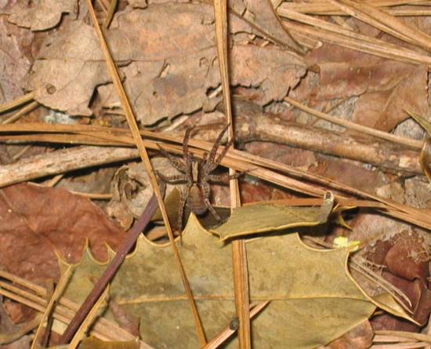
The monotonous landscape of Wicomico forests today provides a much less diverse habitat for animals. A habitat that is more diverse can provide more and varied food sources to support more creatures than a monoculture. In a diverse habitat you can be sure that one of the plants will be producing nuts, berries, pine cones, or some other type of food source at all times. Aquatic species may be affected due to the lack of deadwood in our managed forests as well as the different types of leaf litter that fall from the different types of forests. In removing vast stretches of forested land we removed a lot of important habitat and with it many important wildlife species. Many of the animals that were once found here required vast stretches of uninterrupted forests in order to survive here. The now highly segmented forests that we have can not provide the same safe habitat as the forests of the past.
Animals that could have been encountered in this historic Wicomico County forest are red wolves, deer, wild turkey, black bears, beavers, Delmarva Fox Squirrels and mountain lions. Other animals that were spoken of by some of the first explorers of the Delmarva Peninsula are the flying squirrel, elk, minks, opossums, and lynxes. Some of these animals have been restored to this area, but the red wolf, black bear, and mountain lion have not been. Rattlesnakes also used to reside on the Delmarva Peninsula and are no longer found here. There are also species that existed here at one time that are now completely extinct, they include the Carolina parakeet and the Passenger Pigeon. Many of the larger predators that are no longer found here are gone because humans felt them to be a threat and hunted them out of the area. The Passenger Pigeons extinction is thought to be due to its use as a source of cheap meat and the destruction of its habitat. Many of the animals listed prefer large stretches of mature forest as habitat. As we alter the habitat to better fit our needs, we are often altering so that it no longer suits the needs of certain wildlife. By changing that makeup of the forest, and making the forest less diverse, we in turn affect the animals that live in forests, making them less diverse as well. For instance the Delmarva Fox Squirrel likes to eat the nuts of hardwood trees and nest in old hollowed out trunks of hardwoods in mature forest. The Fox Squirrel prefers to live in large stretches of forest as apposed to small segments. The Delmarva Fox Squirrel is now only found in small pockets of forestland land in Wicomico County. They are only found on this land because they have been reintroduced. These are just the animals that we can see. What about all the microbes, insects, and other small beings who we may have never even identified whose habitat we have changed forcing them out?

Water Quality

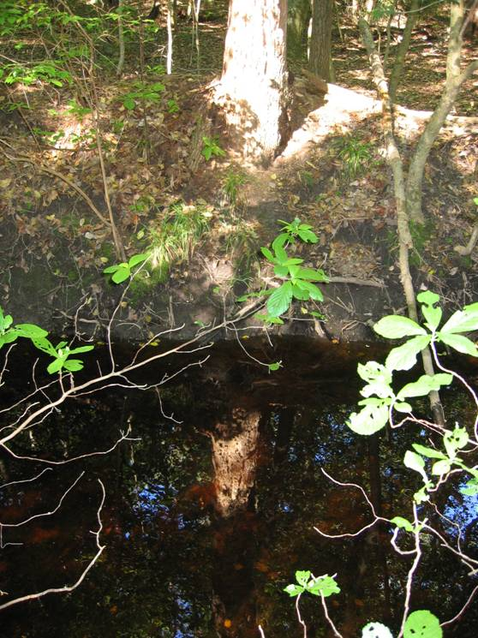

Forests are good for enhancing water quality because they slow down runoff and trap particles and substances that would otherwise end up in streams. Riparian buffers are especially important because they serve this role as well as serve to prevent erosion of the stream bank. Any kind of forest land-use will improve the water quality of a stream when compared to fields or development; however native forests are thought to be the most efficient at this process.
One study was done comparing the effects of different land uses on stream quality, the three land uses compared were a native mixed broadleaf forest (deciduous), a pine plantation, and a pasture. The pine plantation stream tested had more suspended solids (which are insoluble particles suspended in the water) and was wider than streams in the native mixed forest. Suspended solids are bad because they cause turbidity which blocks light from getting to plants that grow under the water which provide food and habitat for animals. Widening of streams can also be a negative thing because it allows the stream to flow quicker and it is the result of shoreline erosion. Both of the forest areas had better water quality associated with them than did the pasture. This demonstrates how changing our native landscape to a manmade less diverse landscape can directly affect stream and water quality.

A Breath of Fresh Air

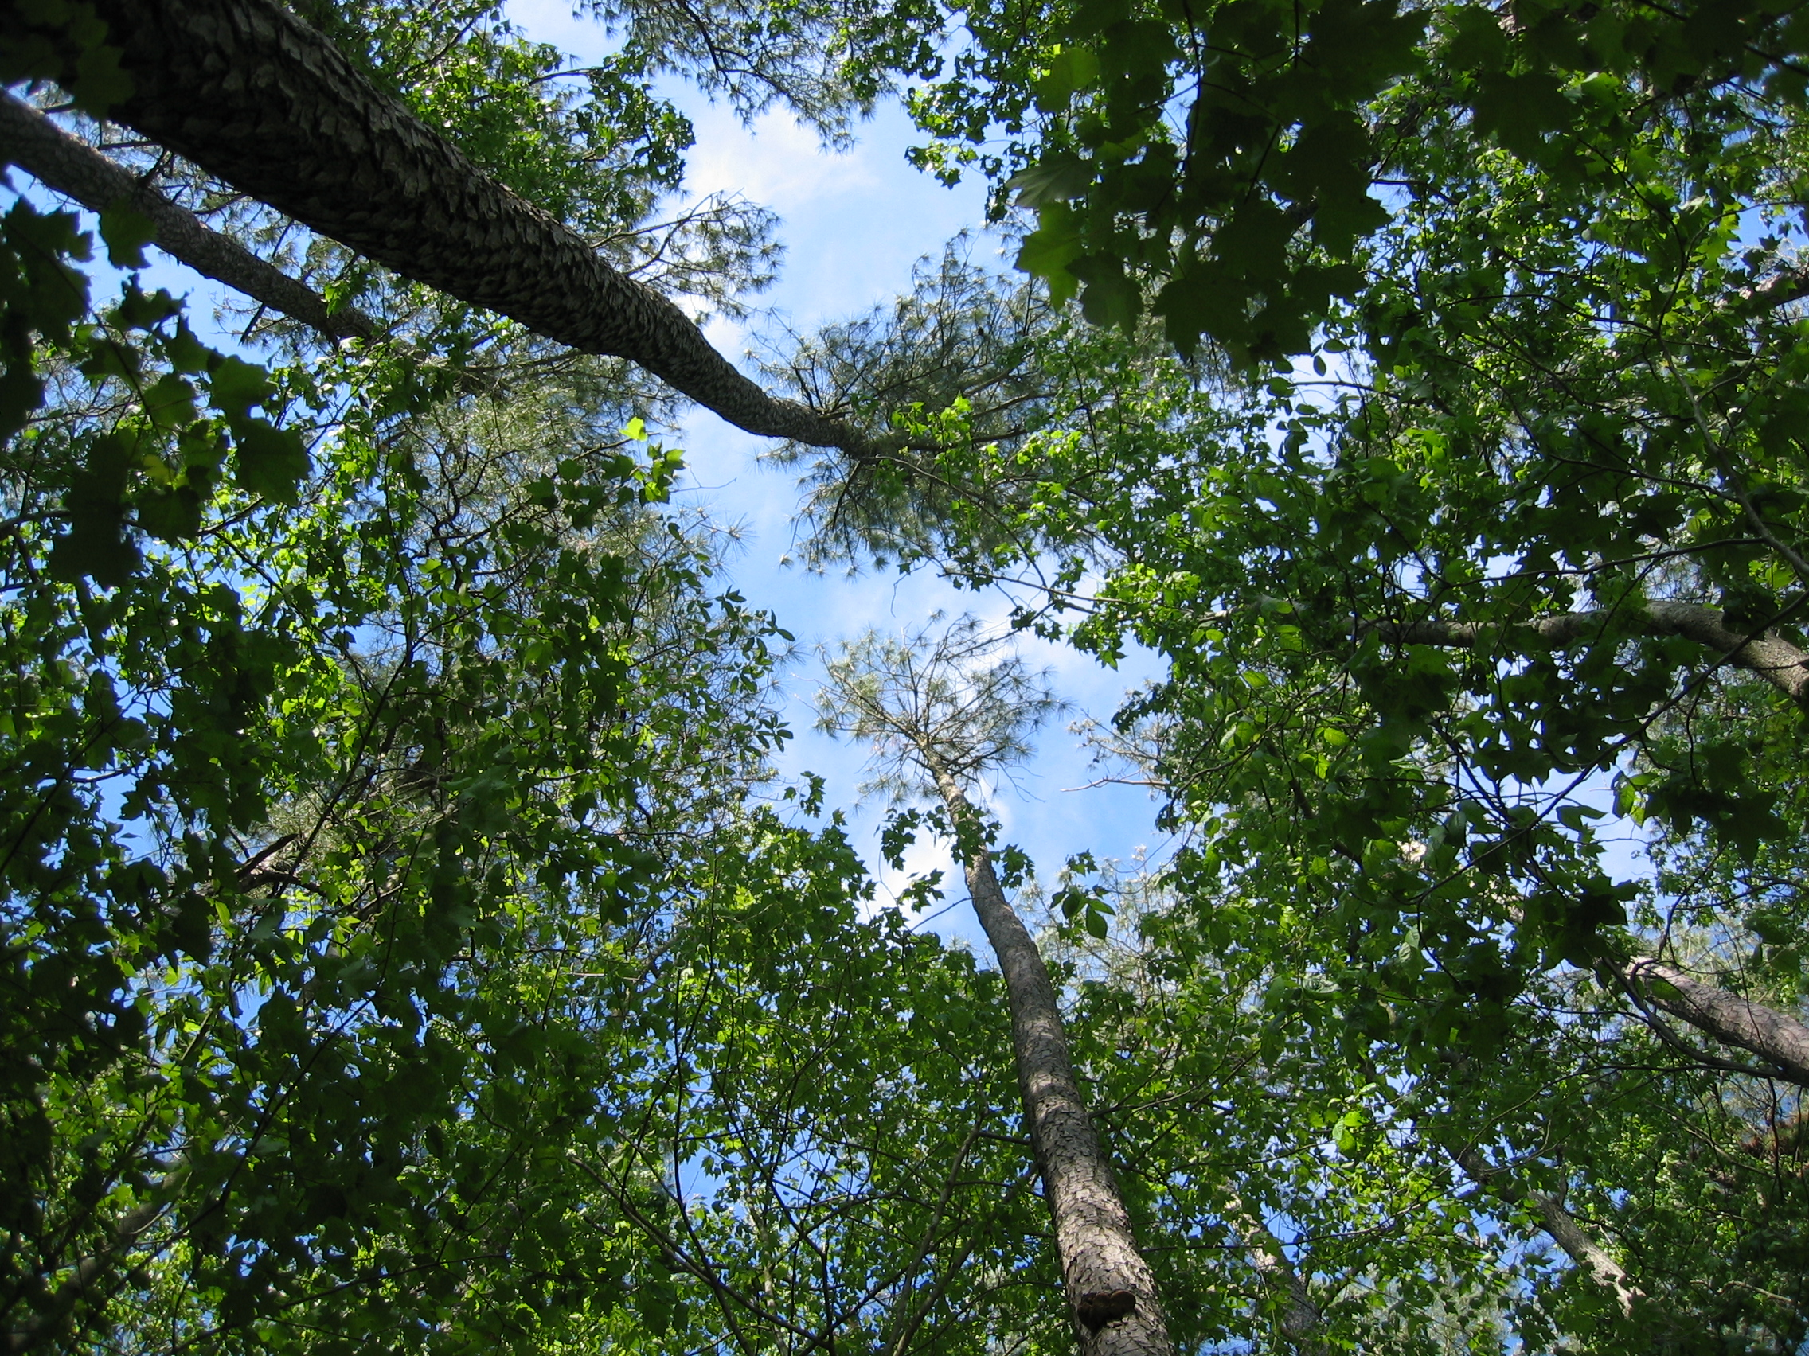

Joan Maloof’s book, “Teaching the Trees” describes the phenomenon of old growth air. She talks about how in the Japanese culture breathing forest air is actually considered to have many health benefits. There are many compounds that can be found in an analysis of air within a forest, many that we can not identify. In a forest with a diverse array of trees and plants, we could expect the number of compounds in the air to be larger.
Trees also can actually act as filters of the air, not only taking in chemicals that are in the air, but even particles. Trees with leaves that have a larger surface area are able to collect more particles. This makes air more breathable for us because it can remove things like fungal spores that we do not want to breathe. Loblolly pines are coniferous which means that they have needles, which compared to deciduous leaves have a very small area, meaning it is likely that they would collect fewer particles from the air. Some conifers are able to filter more particles because they have so many needles from the ground all the way to the top of the tree that the total surface area of leaf is greater. However the Loblollies in our forests usually have needles starting at least half way up the tree and they usually do not look very densely packed with needles. Coniferous trees can filter more chemical pollutants than deciduous trees because they are active during more of the season than deciduous trees. However deciduous trees are also more resistant to air pollution than are conifers. These strengths and weaknesses of each type of tree show that the most efficient forest would be a mixed forest. It is well known that forests help to provide us with clean breathable air, but to what extent some of the other compounds that the trees excrete could help us we may never know.

Who Cares about Dirt?
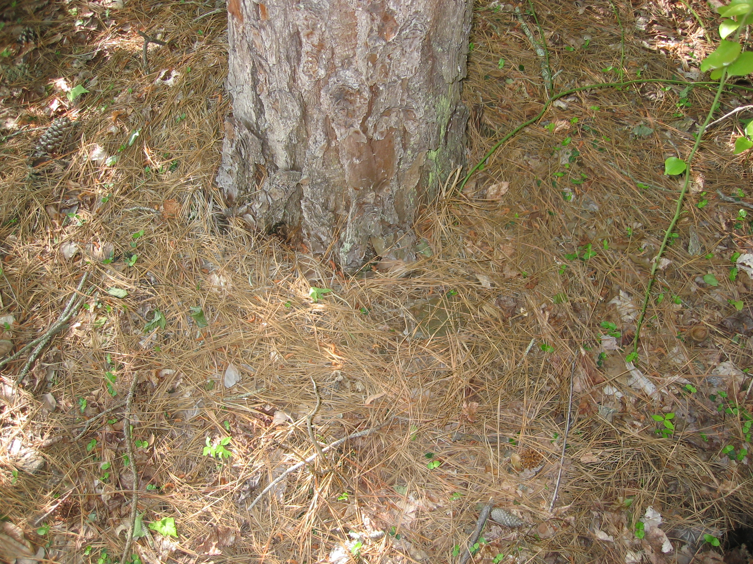
Pine needle debris in Chesapeake Forest Lands
Source: Megan Green
In the writings of Father Andrew White it was actually noted that the soil in Maryland at the time of settlement was so excellent and rich that it was nearly impossible to walk through the forest without trampling over fruits growing on shrubs on the ground and fallen nuts and berries. Soil in mixed forests is often less acidic than that in pine monocultures and can support different life. For instance the red-backed salamander, which is commonly found in older growth deciduous forests on the eastern shore of Maryland, are not often found in pine monocultures because the acidity interferes with their skin breathing.
You can not see it when you are just walking around in the forests but the smaller organisms are affected by this change too. There are fewer small organisms that work to decay fallen needles in comparison to those that are found in the decaying matter in a mixed forest. In general pine needles break down slower than leaves from deciduous trees. Fungus is more likely to engage in the decomposition of pine needles, as bacteria are more sensitive to the acidic conditions. In a study done on the decomposition of pine needles the pH of decaying debris was found to be between 3.26 and 3.47. This is a very acidic pH. In another study completed by William Thomas the number of microorganisms found in litter bags containing both deciduous leaves and pine needles was found to be almost twice that of those found in litter bags containing only pine needles. This implies that the pine needles are broken down much slower than leaves from deciduous trees. Over time then we would expect that the layer of debris beneath the pine tree would build up more than the layer of debris beneath a deciduous forest.
There was also greater species diversity within the litter bags containing both types of litter when compared to those that contained pine needles only. This shows that a greater number of insects, bacteria, fungus, and other detritivores work to decompose the deciduous leaf litter, and that mixed litter is a better habitat for a greater range of species.

Hoping for a Broader Future

Since the time of settlement, Wicomico County’s forests have gone through major changes in their composition. Not only have the types of trees present made a switch, but the associated ecosystems have also been altered in response. From being a mostly hardwood forest, to being totally burned and cut for agriculture land-uses, to the current pine dominated forests of today, the forests have become less diverse. While any forestland serves purposes to provide habitat, filter air and keep water clean, a more diverse forest can handle these tasks more efficiently. Broad leafed trees are very important to the ecosystem as well as to humans as has been demonstrated in this essay. However it is not a switch to a completely broad leafed forest that is needed, what we are in need of is an increase in diversity in Wicomico County forests.
Because the switch to a less diverse forest negatively impacts the effectiveness of the forests to improve habitat, air, and water it is important for us to try to increase the biodiversity in our forests. It is a process that will not happen over night like a clear-cut, but instead it will take hundreds of years for parts of the forest to regain substantial biodiversity. While it is also important to serve the timber needs of the people, perhaps we could work harder to allow some of the forestland to become more diverse as it was when we found it so that it can better suit the needs of the ecosystem as well as our needs. It is not possible to return the forests to the exact state that they were when we found them, even if we completely stopped logging because there are species that were once found here that no longer exist. However it is possible for the forests to become much more diverse than their current state.

Father Andrew White, “A Brief Relation of the Voyage unto Maryland,” Edited by Clayton C. Hall, (New York: Charles Scribner's Sons, 1910), 45.
A.G Bradley, “Travels and Works of Captain John Smith,” (New York: Burt Franklin, 1910), 414.
Bradley, 417.
Anonymous. “Sweetgum: Liquidambar styraciflua,” http://www.fcps.k12.va.us/StratfordLandingES/Ecology/mpages/sweetgum.htm accessed April 9th, 2006.
Anonymous. “Willow Oak: Quercus phellos,” http://www.fcps.k12.va.us/StratfordLandingES/Ecology/mpages/willow_oak.htm accessed April 9th, 2006.
Maryland Department of Natural Resources. “Sustainable Forest Management Plan for Chesapeake Forests Lands,” Chapter 2, Page 32, http://www.dnr.state.md.us/forests/sf_mgt_plan.asp accessed April 7, 2006.
Charles H. Fithian, “A good and Fruitful Land Colonists, Archaeology and the Environment,” Outdoor Delaware (Fall 1994), 23.
Helen C Rountree and Thomas E. Davis, “Eastern Shore Indians of Virginia and Maryland,” (Charlottesville: The university Press of Virginia, 1997), 10.
Erin Kulynyez, Chris Brian and Michael Folkoff. “Forest Composition of 17th Century Somerset County, Maryland,” http://www.salisbury.edu/schools/henson/biology/Briand/Research/Research.html accessed April 25, 2006
Jonathan Kays. “Woodland Management: Maryland’s Forests--Past, Present and Future,” http://www.agnr.umd.edu/MCE/Publications/Publication.cfm?ID=79 accessed March 30th, 2006.
Kays.
Jane Scott, “Between Ocean and Bay, A Natural History of Delmarva,” (Maryland: Tidewater Publishers, 1991), 16.
J.L Kirwin and H.H. Shugart, “Vegetation and two indices of fire on the Delmarva Peninsula,” Journal of the Torrey Botanical Society 127 no. 1 (2000), 44-50.
Maryland Department of Natural Resources, “Sustainable Forest Management” pg 32.
David Suzuki. “Deadwood Brings New Life,” http://www.magicalliance.org/forests/deadwood.htm accessed April 6th 2006.
Susan C. Loeb, “ Response of small mammals to course woody debris in a southeastern pine forest,” Journal of Mammology Vol. 80, No. 2 (May, 1999) , pg. 460.
Eleonora H. Trotter, “Woody Debris Forest-Stream Succession and Catchement Geomorphology,” Journal of the North American Benthological Society, Vol. 9, No. 2 (1990), 141.
Richard H. Waring and William H. Schlesinger, “Forest Ecosystems Concepts and Management,” (Florida: Academic Press, INC, 1985), 184.
David Suzuki.
Maryland Department of Natural Resources, “Water Quality and Wildlife Habitat.”
Maryland Department of Natural Resources, “Water Quality and Wildlife Habitat.”
Dr. Judith Stribling, May 4th, 2006, Personal Communication.
Jack McCormick, “The Life of the Forest,” (New York: McGraw-Hill Book Company, 1966), 44.
Stribling.
McCormick, 52.
Stribling.
Maryland Department of Natural Resources, “Sustainable Forest Management” pg 28.
Grace Brush, Cecilia Lenk, and Joanne Smith, “The Natural Forests of Maryland: an Explanation of the Vegetation Map of Maryland,” Ecological Monographs 50 no.1 (1980), 82.
Maryland Department of Natural Resources, “Sustainable Forest Management” pg 28.
Maryland Department of Natural Resources, “Water Quality and Wildlife Habitat in Pine Stands on Delmarva.”
Joan Maloof, “Teaching the Trees, Lessons from the Forest,” (Georgia: University of Georgia Press, 2005), 65.
Kirwin and Shugart, 46.
Maryland Department of Natural Resources, “Sustainable Forest Management” pg 28.
W.S Hamill, “The Forest Resources and Industries of Maryland,” 1937, pg 50.
Maryland Department of Natural Resources, “Sustainable Forest Management” pg 32.
Kays.
Maryland Department of Natural Resources, “Sustainable Forest Management” pg 28.
Scott, 45.
Deidra Brace. “Chesapeake Forest Continuous Forest Inventory Field Inventory Report,” Maryland Department of Natural Resources July, 2005.
Kays.
Kays.
Deidra Brace, Pg 3.
Anonymous, “Final Report, Discussion and Conclusions,” http://www.srs.fs.usda.gov/sustain/report/hlth2/hlth2-19.htm accessed April 11th, 2006.
Anonymous, “Final Report.”
Anonymous, “Final Report.”
Peter L. Lorio, Jr, “Growth-Differentiation Balance: A Basis for Understanding Southern Pine Beetle-Tree Interactions,” Forest Ecology and Management 14 (1986) 259.
Beetle Bugs Loblolly Pine, The Washington Post Times Herald, April 27 1971 Proquest Historical Newspapers The Washington Post.
Beetle Bugs Loblolly Pine.
McCormick, 26.
Robert J. Marquis and Christopher J. Whelan, “Insectivorous Birds Increase the Growth of White Oak through Consumption of Leaf Chewing Insects,” Ecology 75 no. 7 (1994), 2008.
Jeffrey Sayer, Unna Chokkalingam, and John Poulsen “The restoration of forest biodiversity and ecological values,” Forest and Ecology Management 201 (2004), 3.
Carrie Samis, April 11th, 2006, Personal Communication.
Scott, 69.
Samis.
Scott, 65.
Samis.
John M. Quinn, Bryce Cooper, Robert J. Davies-Colley, J. Christopher Rutherford, and R. Bruce Williamson, “Land use effects on habitat, water quality, periphyton, and benthic invertebrates in Waikato, New Zealand, hill-country streams,” New Zealand Journal of Marine and Freshwater Research 31 (1997), 579.
Maloof, 3.
Maloof, 3.
Per Bolund and Sven Hunhammar, “Ecosystem services in urban areas,” Ecological Economics 29 (1999) 295.
Per Bolund and Sven Hunhammar, 295.
White, 45.
Maloof, 27.
William A. Thomas, “Decomposotion of Loblolly Pine Needles With and Without Addition of Dogwood leaves,” Ecology 49 no. 3 (1968), 569.
John R. Packman and David J. L. Harding, “Ecology of Woodland Processes,” (London: Edward Arnold Publishers Limited, 1982), 189.
Dan Binkley, “Ten-year decomposition in a loblolly pine forest,” Canadian Journal of Forestry Resources 32 (November 2002), 2232.
William A. Thomas, 568.
William A. Thomas, 570. Bibliography A.G Bradley, “Travels and Works of Captain John Smith,” New York: Burt Franklin, 1910. Anonymous, “Endangered Delmarva Fox Squirrel: Native of the Chesapeake Watershed http://www.fws.gov/chesapeakebay/dfox.htm Anonymous, “Final Report, Discussion and Conclusions,” http://www.srs.fs.usda.gov/sustain/report/hlth2/hlth2-19.htm accessed April 11th, 2006. Anonymous. “Sweetgum: Liquidambar styraciflua,” http://www.fcps.k12.va.us/StratfordLandingES/Ecology/mpages/sweetgum.htm accessed April 9th, 2006. Anonymous. “Willow Oak: Quercus phellos,” http://www.fcps.k12.va.us/StratfordLandingES/Ecology/mpages/willow_oak.htm accessed April 9th, 2006. Beetle Bugs Loblolly Pine, The Washington Post Times Herald, April 27 1971 Proquest Historical Newspapers The Washington Post. Carrie Samis, Salisbury Zoological Park, April 11th, 2006, Personal Communication. Charles H. Fithian, “A good and Fruitful Land Colonists, Archaeology and the Environment,” Outdoor Delaware Fall 1994. Dan Binkley, “Ten-year decomposition in a loblolly pine forest,” Canadian Journal of Forestry Resources 32 November 2002. David Suzuki. “Deadwood Brings New Life,” http://www.magicalliance.org/forests/deadwood.htm accessed April 6th 2006. Deidra Brace. “Chesapeake Forest Continuous Forest Inventory Field Inventory Report,” Maryland Department of Natural Resources July, 2005. Dr. Judith Stribling, Salisbury University, May 4th, 2006, Personal Communication. Eleonora H. Trotter, “Woody Debris Forest-Stream Succession and Catchement Geomorphology,” Journal of the North American Benthological Society, Vol. 9, No. 2 1990. Erin Kulynyez, Chris Brian and Michael Folkoff. “Forest Composition of 17th Century Somerset County, Maryland,” http://www.salisbury.edu/schools/henson/biology/Briand/Research/Research.html accessed April 25, 2006 Father Andrew White, “A Brief Relation of the Voyage unto Maryland,” Edited by Clayton C. Hall, New York: Charles Scribner's Sons, 1910. Grace Brush, Cecilia Lenk, and Joanne Smith, “The Natural Forests of Maryland: an Explanation of the Vegetation Map of Maryland,” Ecological Monographs 50 no.1 1980. Helen C Rountree and Thomas E. Davis, “Eastern Shore Indians of Virginia and Maryland,” Charlottesville: The university Press of Virginia, 1997. Jack McCormick, “The Life of the Forest,” New York: McGraw-Hill Book Company, 1966. Jane Scott, “Between Ocean and Bay, A Natural History of Delmarva,” Maryland: Tidewater Publishers, 1991. Jeffrey Sayer, Unna Chokkalingam, and John Poulsen “The restoration of forest biodiversity and ecological values,” Forest and Ecology Management 201 2004. J.L Kirwin and H.H. Shugart, “Vegetation and two indices of fire on the Delmarva Peninsula,” Journal of the Torrey Botanical Society 127 no. 1 2000, 44-50. Joan Maloof, “Teaching the Trees, Lessons from the Forest,” Georgia: University of Georgia Press, 2005. John M. Quinn, Bryce Cooper, Robert J. Davies-Colley, J. Christopher Rutherford, and R. Bruce Williamson, “Land use effects on habitat, water quality, periphyton, and benthic invertebrates in Waikato, New Zealand, hill-country streams,” New Zealand Journal of Marine and Freshwater Research 31 1997. John R. Packman and David J. L. Harding, “Ecology of Woodland Processes,” London: Edward Arnold Publishers Limited, 1982. Jonathan Kays. “Woodland Management: Maryland’s Forests--Past, Present and Future,” http://www.agnr.umd.edu/MCE/Publications/Publication.cfm?ID=79 accessed March 30th, 2006. Maryland Department of Natural Resources. “Sustainable Forest Management Plan for Chesapeake Forests Lands,” Chapter 2, Page 32, http://www.dnr.state.md.us/forests/sf_mgt_plan.asp accessed April 7, 2006. Maryland Department of Natural Resources, “Water Quality and Wildlife Habitat in Pine Stands on Delmarva,” http://www.dnr.state.md.us/forests/download/water_wildlife.pdf accessed April 7, 2006. Per Bolund and Sven Hunhammar, “Ecosystem services in urban areas,” Ecological Economics 29 1999. Richard H. Waring and William H. Schlesinger, “Forest Ecosystems Concepts and Management,” Florida: Academic Press, INC, 1985. Robert J. Marquis and Christopher J. Whelan, “Insectivorous Birds Increase the Growth of White Oak through Consumption of Leaf Chewing Insects,” Ecology 75 no. 7 1994, 2008. Rountree, Helen C. and Thomas E. Davidson. Eastern Shore Indians of Virginia and Maryland. Charlottesville, VA: University of Press of Virginia, 1997. Schultz, Robert P. Loblolly Pine: The Ecology and Culture of Loblolly Pine. Washington D.C.: U.S. Department of Agriculture, Forest Service, December 1997. Susan C. Loeb, “Response of small mammals to course woody debris in a southeastern pine forest,” Journal of Mammology Vol. 80, No. 2 May, 1999. William A. Thomas, “Decomposotion of Loblolly Pine Needles With and Without Addition of Dogwood leaves,” Ecology 49 no. 3 1968. W.S Hamill, “The Forest Resources and Industries of Maryland,” 1937.

